Understand Norwegian sites by getting them translated to your language.

The most uncomplicated way that fits all is to, if you are not using Chrome*:

1. Find the site you like to read.
2. Copy the URL from your browser may look something like this:

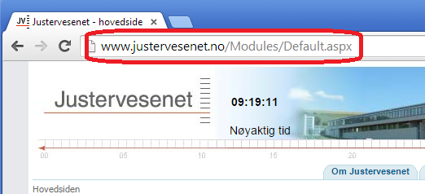

(Mark it with your data-mouse and copy by using keys Ctrl+C)

1. Go to this [site](http://itools.com/tool/google-translate-web-page-translator)

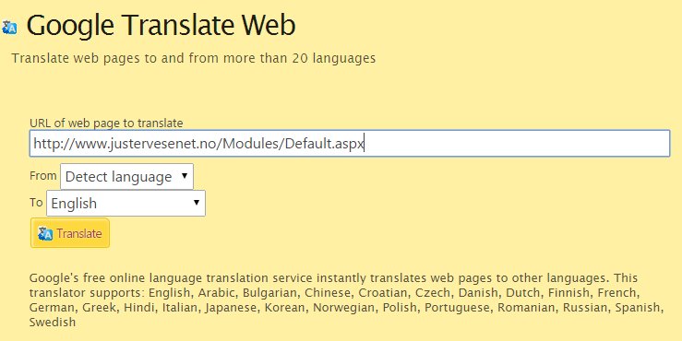

1. Type in the URL of the webpage you like to read. (Paste it by using the keys Ctrl+V)
2. It may be faster if you change the ‘From’ language, to Norwegian
3. Choose the language you read best, like English.
4. Click Translate
5. The ‘Translate site’ will now take you to the translated site.

The site in this example already gives the option of choosing English, and this service will of course provide a much better grammar for English than a mechanic translation.

A more automatic translation of sites you may visit, can be achieved by using the [Google Toolbar](http://www.google.com/toolbar/ie/features.html), but then you will have to take in to account what browser you use, and sometimes you get unwanted programs together with this downloads.

For more information on Google Toolbar and the translating service, take a look at point 3 [here](https://support.google.com/toolbar/answer/81376?hl=en).

If you use [Internet Explorer](http://www.microsoft.com/nb-no/download/internet-explorer.aspx), take a look at this [site](http://www.google.com/toolbar/ie/install.html).

If you regret, you may [Uninstall Google Toolbar](https://support.google.com/toolbar/answer/9231?hl=en)

*If you are using [Chrome](http://www.google.com/chrome/), that's great.

All of the features of Google Toolbar are already built into your browser.

For Chrome user help on translating a page to your language, look [here](https://support.google.com/chrome/answer/173424?hl=en).